Chapter 1
Title: Study and Implementation of IoT Attendance System for Fingerprint Recognition

1.0 Overview
In this chapter, we will be going more in depth about the system that we are trying to develop. The system is essentially using a scanner to scan the students’ fingerprints and after verifying the thumbprint of the students their attendance will be marked automatically with the least human interactions and after that, the recorded attendance can then be accessed in a web application by the administrators and lecturers. Hence, the rest of the content below is just to get a clearer understanding of the system that includes the objectives, users of the system, the functions and features available and much more.

1.1 Introduction
Background of System
The main function of this system is to use biometric characteristics of students so that it will prevent any impersonation since everyone’s thumbprints will be unique, specifically their thumbprints to take their attendance by scanning and validating the thumbprint which will then be accessed in the web application for the users except for the students. Therefore, this system’s very core is based on one of the Industrial Revolution Technology which also known as IR4.0 that falls under the category of the Internet of Things that uses a microcontroller ESP32. All in all, the implementation of the system can help improve the efficiency and effectiveness of taking students’ attendance as it can reduce human error, reduce time, and prevent impersonation of the students.

Targeted Users and the Benefits towards Users
Students:
The students are the primary users that will scan their thumbprint to record their attendance.
Benefit : Students attendance can be automatically recorded with minimal human interaction. Moreover, the process of taking attendance will have less human error unlike the current methods where lecturers may accidentally skip the student’s attendance. Additionally, it creates fairness within the students where students that did not attend the class will not be able to have their attendance recorded since their friends cannot impersonate them with this new method of taking attendance.

Lecturers:
The lecturers will have access to the web application where they will be provided with the attendance that has been recorded and will have some additional features mainly to help in analyzing the attendance list which will be furthered explored in this chapter.
Benefit : Lecturer can focus more on teaching the students unlike the current methods that require lecturer to take out some time just to record attendance which is very time consuming especially if the class has a large number of students. Not only that, but lecturers also have easy access to the recorded attendance with functions to mainly help ease analyzing the recorded attendance.

Other than that, administrators do also have access to the web application and will be provided with some functionalities for them to manage and maintain the system properly, which will be further discussed in this chapter.

Tools and Platform to Support System
ESP32 and AS608:
The ESP32 will be served as the microcontroller of the scanner where it will provide the necessary network connection for data transmission of receiving and sending put data like receiving thumbprint data stored in the database to validate the thumbprint and sending out signals to automatically record attendance. In addition to that it will also be responsible of handling the processing side where it has to validate and verify the thumbprint being scanned is legitimate to then record the attendance after passing the validation. AS608 will serve as a scanner where it can capture thumbprints for administrators to register students and to have an input for validation process before recording the attendance.

PHP, HTML, CSS & Arduino:
These scripting and programming languages mentioned will provide the coding side of the system that includes its frontend which is the framework where the HTML will contribute and the CSS to provide a more visually attractive web application for lecturers and administrators ,and the backend where the PHP main purpose is to provide ensures the functions runs on the web application side. As for the Arduino will provide the code for handling the device side specifically the microcontroller, to make sure it performs the intended functions like validating and automatically record attendance as well as capture thumbprint for registrations of students.

MySQL:
This provides the system with a relational database to be able to store the data efficiently and neatly for further use.

XAMPP:
The XAMPP is an open source tools that will provide the local server to create the necessary environment to be able to run the web application side using the Apache tool. Furthermore, the database will be managed by using the tool PhpMyAdmin provided by XAMPP.

Others:
LED Light Diodes: To indicate if device is on, if the device has recorded attendance, if the device was unable to record the attendance.
Wires: To connect the device together that includes the scanner, microcontroller, and power supply
Breadboard: To act as a medium of holding the hardware together.
AAA Batteries: To provide the power for the device to run.
AAA Battery Holder: To provide the AAA Batteries to be put in pace to create the circuit
Ohm resistors: To provide some resistance so that LED Light Diodes do not burn out

Problem Statement:
The problem lies within the way students in INTI International University take their students’ attendance since the current methods is mainly through lecturers calling the students name individually which the students respond the lecturer to indicate that they are present and the lecturer then mark their attendance, while the other method is by students passing an attendance list around and ticking on the space provided for their attendance which the problem is that it is extremely time consuming. That is where the proposed system comes in as it only requires minimal human interaction where students just have to scan their thumbprint and their attendance will be recorded provided that the thumbprint is valid.

Market Value:
This is a potential market aimed towards Universities like INTI International University that can be further looked upon as it can ease the process of taking students’ attendance. This is because the current methods mentioned in the problem statement taking attendance are inefficient especially if the class has a lot of students which consumes a lot of time which then essentially increases the chance of human error and also impersonation of students by their friends.

Scope and Limitation
Scope:
In this project aims to develop an IoT Attendance system ease the process of taking attendance of students. This is done by implementing a new method of taking attendance of students that requires minimal human interactions. For example, students are required to scan their thumbprint and if valid the attendance will automatically be recorded. Furthermore, the scope will also include the easy access of lecturers and administrators to be able to access the system easily to access the recorded attendance. In addition, lecturers and administrators will be provided with some additional features to manage attendance efficiently. For example, allowing lecturer to enter reason for absent student, administration can add, update, delete students form the system and so on.

Limitation:
- Users can only access the web application if there is a network connection.
- The web application is only optimized for computer/laptop
- The web application only supports English language where users are not given the option to change the language.
1.2 Project Objectives
Objective 1
To research about Internet of Things Technology to understand how devices connect to exchange data:

This project objective is achieved by commencing online research of the Internet of Things Devices on how they receive and send out data. After understanding the concept of the data transmission, the research will then further be aiming towards the implementation on coding mainly on the Internet of Things device which is the microcontroller (ESP32) to receive and send out the data from/to the MySQL database.

Objective 2
To study about thumbprint recognition to understand how thumbprint is applied into systems:

This project objective is achieved by reading doing research into the thumbprint recognition to understand the concept of how the scanner works. Then the research will then continue that is more into the practical side to be able to start on the implementation into the system to be able to scan student’s thumbprint.

Objective 3
To study web application to develop a complete website for end users to access:

This objective is achieved through learning form the internet including Google, YouTube on how to implement software and tools including HTML that provided the framework of the system, PHP that provides the backend of the web application, and CSS that allows styling of the web application, to develop a fully functional the web application for users and administrators to access. In addition, further research on the implementation of a server specially the XAMPP server is done to be able to run the web application that is developed.

Objective 4
To conduct system testing to evaluate the efficiency and effectiveness of the system:

This objective will be achieved by going through a well comprehensive testing to properly evaluate whether the system is successful in delivering the functions promised. The testing is tested by looking if the system is both effective and efficient as both of these elements determine if the system is well implemented, which can be furthered for deployment if the results tested are well.

1.3 System Description
Function 1
Take attendance of every students by scanning their thumbprint :

As mentioned before, the main function for the system is to take student’s attendance. This is done by scanning students, biometric characteristics or more specifically their thumbprint. The scanner will first capture the thumbprint and then match the thumbprint with the other thumbprint stored in the database. After validation the microcontroller (ESP 32) will then send a signal to the database marking their attendance.

Function 2
Allow lecturers to enter the reason for absent student :

This function allows lecturers to enter in the reason of the student provided that the reason has been approved by the HOP so that the attendance of the students is not affected. This function is crucial as if the student’s attendance is not properly recorded and managed can cause problems like students who should be allowed into the final exam are barred and therefore denied since the system had not properly recorded the system.

Function 3
Lecturers can individually check on each student’s attendance status:

This function allows the lecturers to be able to look up on each individual student’s attendance in that class that provides details on the student attendance and percentage so that they can have a better picture of each student’s attitude towards the subject. This in turn allows the lecturer to be able to communicate and notify the students if their attendance is almost or are below the 80% requirement which creates a sense of care into students’ academics.

Function 4
Generate report of which student has attendance below 80%

This function allows users to generate a report of the students’ that are below the 80% attendance percentage of each subjects that they are enrolled in. This is a beneficial function that needs to be implemented because they can help in enforcing the policies which are barring these students from final exams so that these students do not get away with this attitude without any consequences.

Function 5
Admin can register or assign lecturers to subjects:
This function allows the administrator to assign the lecturers to subjects, so that when the lecturer accesses the web application the subjects that they are currently teaching will already be available. Therefore, this provides more efficiency as it does not require lecturers to manually find the subjects they are teaching while it also uses the concept of least privilege access thought during the cybersecurity class as it also limits the access of lecturers by giving them minimal access to the attendance list that they are teaching and nothing more.

Function 6
Admin can register, update, remove students’ information for attendance:

This function allows administrators to access and manage students’ information performing activities like adding, removing, and updating the student’s information. This is added so that the admin is able to provide the system with the necessary data in order for the system to mark the student’s attendance since the scanner can only work if it contains information like the thumbprint, ID number, their name and so on.

1.4 Studies of existing systems
Paper 1
Their problem that they are trying to resolve stems from the same problem that we are trying to solve ourselves. The system proposed also uses a fingerprint based method which eases the attendance process and mainly prevents impersonation. The system proposed includes various elements like a web based platform to allows easy accessibility, a database to store any relevant data including the fingerprint samples and security whereby sensitive data like the fingerprint has been hashed to be able to prevent any impersonation. After reviewing with of the paper, it now serves as a general guide as to how out system might look like with some different key elements.

Paper 2
In this system they have developed a student attendance system with the aim of more reliability and efficiency. Their system mainly focuses on the one main function of the system that uses a database only to look at the student’s attendance and does not provide any additional features. Therefore, their system could be improved so that there can be more accessible and efficient. It has been stated that the system was a success with a very high accuracy of 98.833% for identification of the attendance system. This paper provides us with the confidence that if the system is developed properly can have a high success rate to take students’ attendance.

Paper 3
This system does also use fingerprint recognition to mark attendance. However, this system uses a mobile application and uses Firebase instead of the typical MySQL database. In addition, the process of taking students’ attendance also differs requiring the student to enter their name and ID in the app while also including the fingerprint scanning to take the attendance system. This system proposed although was claimed to be efficient in their conclusion but it does not seem so as this different process requires additional steps that can be easily fixed by associating the fingerprint with the name and ID into the database which reduces the number of steps, thus making it more efficient.

Paper 4
This system is constructed from 3 subsystem including a cloud based server and database system to process and save attendance, a device to capture the attendance( fingerprint scanner) for enrollment and attendance and a mobile application for lecturers to view the students’ attendance. In their testing the system took 45 seconds to capture 10 of the students’ attendance which is extremely efficient given that on average it takes 4.5 seconds to take one of student’s attendance. One element that was mentioned is that they have applied encryption onto the lecturers’ passwords and server codes to prevent hacking. This system that has been proposed performed very well with not only a responsive system but with a somewhat secure element to it.

Paper 5
In this system they are also developing an attendance system for Cros River University of Technology (CRUTECH). They have given very detailed documentation of their system which provided pictures and diagrams regarding every hardware used and the circuit of how the layout for the system and registration. This system also provides a web application for admins. Although this system is somewhat comprehensive in guiding us the whole structure of the system itself, it also lacks some additional features as the web application is only for administrators to access and manage leaving lecturers or even students uninformed of the attendance.

Paper 6
The proposed system is known as Fingerprint-Based Attendance Management System (FAMS) and it aims to solve the traditional way of taking attendance. The system can only be accessed by the administration to update, delete, add and assign for departments, courses, lecturers and students. The attendance is taken by matching the fingerprint scanned with the other fingerprint stored in the database together with the courses that was enrolled. This system also seems to have daily attendance report function that generates a simple list of the attendance.

Paper 7
The system proposed in this also has a different proses in taking the attendance. The system first checks to see if the fingerprint matches or not. If so it uses a buzzer to indicate if the attendance is taken or not where it buzzes one seconds means successfully and it buzzes two time to indicate unsuccessful. The system also provides a web application to check the attendance. However, this system only provides a simple list of the people who attended the class or not and no other additional features which limit the full potential of the attendance system which can be improved on.

Paper 8
This system proposed is aimed towards the attendance of the employees. This is implemented by requiring employees to scan their fingerprint with the scanner provided and once the fingerprint has been matched it will then directly record their attendance onto their daily time record. Not only that, but the system also generates employees’ daily time record into a report which also takes into consideration their leave forms also. Additionally, the system also has additional features like allowing the user to view who came in to work early, who is on leave and on official business and an attendance statistical dashboard and so on. Overall, this is a very well rounded system that effectively takes the attendance of employees but also additional features, allowing managers/ employers to have well informed overview of the employee’s attendance.

Paper 9
The system proposed in this paper is not as comprehensive although it has provided a formative diagram of the system design. However, it is generic as it only says that the only function is to scan, verify and take the attendance record. This system lacks a lot of features with the main one being administrators or lecturers are unable to easily access the attendance record because in this paper it never any mention of a web or mobile application to access the system. This paper has shown us some of the weakness that we might encounter if we do not implement a more comprehensive system with the necessary features to effectively manage the attendance of students.

Paper 10
The proposed system In this paper has incorporated cryptography into their system which prevents unauthorized tampering of the data stored. They have also stated that their scanner can be used for registration of a new fingerprint or taking attendance of the students. However, it also suffered the same fate as some of the other systems reviewed, which is the application side, which was never mentioned or stated. This lack of the system can definitely be improved upon to make it easier for lecturers and administrators to monitor the attendance record.

Paper 11
In this proposed system they have come up with a more resilient system compared to the other proposed systems as it features a backup method if the primary method fails or takes a very long time in order to take attendance. In this system it provides two ways of taking attendance of student with one being facial recognition and the other is fingerprint recognition which then generates a report of the attendance list. This proposed system is simple yet complete as it not only prepares itself incase if anything goes wrong it can still be able to record attendance. However, the two way attendance may not be necessary as using one method of taking attendance should be sufficient to effectively take students’ attendance.

Paper 12
This proposed system has an interesting and unique concept where the process of taking student’s attendance will begin when the lecturer enters the room and within the 20 minutes students’ attendance will be taken and any students scanning their fingerprint beyond that time will not be recorded into the attendance list. Not only that, but the system will also send out a daily SMS to the student’s parents every day. This unique was of taking student’s attendance is quite unique and needs more testing to be able to see if the concept is efficient or not, and as for the daily SMS updated to the parents is a very interesting and useful function so that the parents are up to date with the child’s academic status.

Paper 13
This proposed system is used to take students’ attendance for examinations which will take place outside the examination hall. It will first scan the student’s fingerprint and then validate it. If the biometric authentication was to fail the teachers are able to enter in the student’s ID. Although this proposed system is trying to implement a fail safe for the system but it does pose a new potential flaw where the teacher does not know the student and is just the invigilator they would not know if the student who failed to scan their thumbprint is actual student or not which needs t be further improved if a fails safe was to be implemented.

Paper 14
This proposed system is a very general and basic fingerprint recognition of the attendance system. In the paper it provided a rundown on each software and hardware used like the ESP8266 microcontroller, MySQL, Node JS and so on of how each component plays apart in the system. The paper, however, never elaborates much on how the administration or lectures will access the data to manage the system as it has also said that the lecturer must login to the system and select the courses in order to allow student to attend. The system can be further improved on as form the paper it only provides function like selection of course by the lecturer only which limits the full potential of the system.

Paper 15
This proposed system has a unique feature similar to one of the systems read before where it sends a message to the students notifying that their attendance is recorded tot heir device. The system also provides a web application to be accessed by the user where it also features the attendance percentage of students. The paper has given ample diagrams and explanation of the system like diagrams pictures of the final products and so on. Overall, this is a great system where still can add more features specifically to the web application side as it currently provides one function where users can see student’s attendance percentage of a subject.

1.5 Summary
In conclusion, this chapter allows readers to have a better understanding of the system as a whole that includes its objectives, the functions, its advantages and so on and so forth. This system will demonstrate the various skills of developing a fully functional system from old concepts to new concepts that must be learned by oneself alone. It is without a doubt that if the objectives were to be achieved indicates that this attendance system was successfully implemented and it would without a doubt reduce the time of taking student’s attendance and overall become more efficient and simpler to track each student’s attendance.

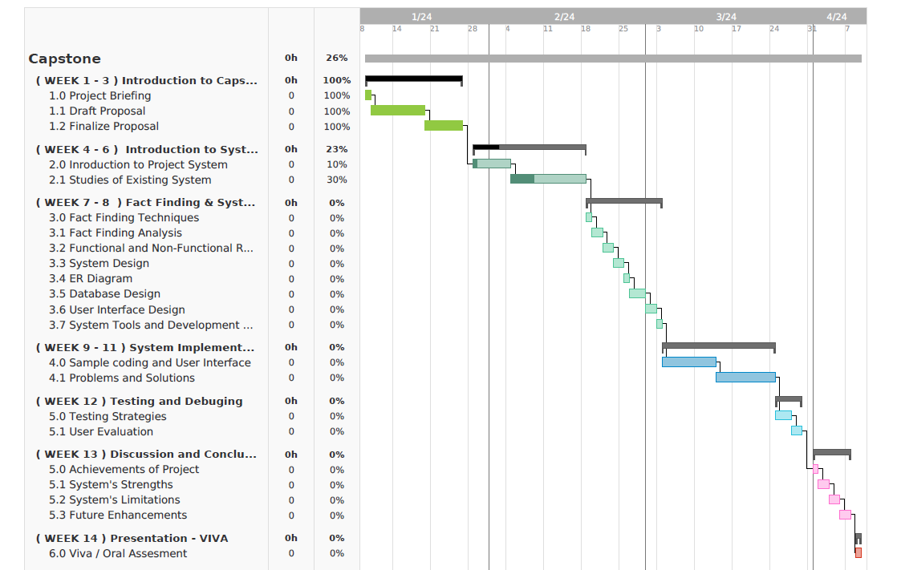
Gantt Chart

